

**ADDENDUM**

January 20, 2025

RE: City of Mobile Bid #5924 for JANITORIAL SUPPLIES

Please consider the following to be Addendum to City of Mobile Bid #5924 for Janitorial Supplies.

**DUE TO FORTHCOMING INCLEMENT WEATHER, THE BID OPENING DATE HAS BEEN CHANGED**

**FROM**

12:01 PM, Thursday, January 23, 2025

**TO**

12:01 PM, Friday, January 24, 2025

Thank you for your consideration in this matter.

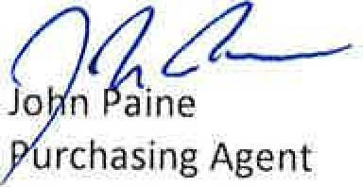

City

of

Mobile

JP/EN

City of Mobile Post Office 1827 Mobile, 36688-1827